**CALENDAR FOR THE WEEK AHEAD**

|  |  |  |  |  |
| --- | --- | --- | --- | --- |
| Sunday | Jun | 24 | 9:00am | Chapel Prayer |
|  |  |  | 9:30am | Courtyard Fellowship |
| Our nursery is staffed from 9:30am – 12:30pm | | | 9:45am | Sunday School |
| 11:00am | Worship |
|  |  |  | 12:15pm | Summer Choir Rehearsal |
|  |  |  | 12:30pm | Fellowship Hall Reserved  Girl Scout Fundraiser Luncheon |
|  |  |  | 7:00pm | Church Council in the Visioning Center |
| Tuesday | Jun | 26 | 9:30am | Food Pantry Volunteer Opportunity |
| Sunday | Jul | 1 | 9:00am | Chapel Prayer |
|  |  |  | 9:30am | Courtyard Fellowship |
|  |  |  | 9:45am | Sunday School |
|  |  |  | 11:00am | Worship |

**JUNE BIRTHDAYS**

|  |  |  |  |  |  |
| --- | --- | --- | --- | --- | --- |
| 2 | Ashley Fuller | 11 | Hope Tyndall | 19 | James Best |
| 4 | Addison Murphy | 14 | Davis Dunbar | 20 | Martha Smith |
| 5 | Jimmy Goodman | 14 | Clarke Welch | 22 | Wendy Spell |
| 10 | Mike McLeod | 15 | Steven Strickland | 28 | Cathy Elmore |
| 10 | Quinn Schmidlin | 16 | Herman Medlin | 30 | Scarlett Coffman |

**Open Date in Altar Flower Schedule**

Is there someone special you would like to honor? We have Sunday, July 29 as an open date in our Altar Flower schedule. If you would like to volunteer in this area, please contact Huntsie Strickland or the church office. Thank you!

**Girl Scout Spaghetti Luncheon – TODAY after Worship**

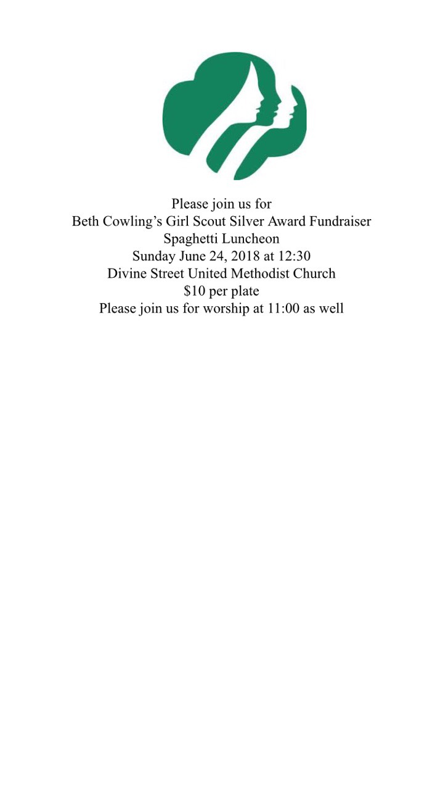 **Everyone is Invited**

**VBS - Shipwrecked: Rescued by Jesus**

**Best Week of the Summer!**

VBS will be Sunday, July 15 (3-5pm) through Thursday, July 19 (9am-Noon on the weekdays). Register online through the church website at [*www.divinestreet.org/vbs-2018---register-today*](http://www.divinestreet.org/vbs-2018---register-today).



“Save the Date” cards are available at our Welcome Center. Take some to share with your friends!

**Church Items Available for Purchase**

|  |  |  |
| --- | --- | --- |
| Divine Family Favorites Cookbook | Divine Street T-shirt | Divine Street Notecards/Envelopes |
|  | 2-Adult Small | Package of 20 |
|  | 3-Adult X-Large |  |
| $10.00 | $15.00 | $10.00 |

All items are available for purchase in the church office.

**Your Support is Appreciated!**

The Outreach Committee extends a huge “Thank You” for all the support and success of the recent Apparent Project Fundraiser.

**Directory Update**

Steve and Mary Ellen Parker

1505 Oak Forest Road

Four Oaks, NC 27524

Pastor Beth will be out of the office Monday, June 24 – Monday, July 2. In case of emergency, please contact the church office or Karen McLeod, SPRC Chair.

**CALENDAR FOR THE WEEK AHEAD**

|  |  |  |  |  |
| --- | --- | --- | --- | --- |
| Sunday | Jun | 24 | 9:00am | Chapel Prayer |
|  |  |  | 9:30am | Courtyard Fellowship |
| Our nursery is staffed from 9:30am – 12:30pm | | | 9:45am | Sunday School |
| 11:00am | Worship |
|  |  |  | 12:15pm | Summer Choir Rehearsal |
|  |  |  | 12:30pm | Fellowship Hall Reserved  Girl Scout Fundraiser Luncheon |
|  |  |  | 7:00pm | Church Council in the Visioning Center |
| Tuesday | Jun | 26 | 9:30am | Food Pantry Volunteer Opportunity |
| Sunday | Jul | 1 | 9:00am | Chapel Prayer |
|  |  |  | 9:30am | Courtyard Fellowship |
|  |  |  | 9:45am | Sunday School |
|  |  |  | 11:00am | Worship |

**JUNE BIRTHDAYS**

|  |  |  |  |  |  |
| --- | --- | --- | --- | --- | --- |
| 2 | Ashley Fuller | 11 | Hope Tyndall | 19 | James Best |
| 4 | Addison Murphy | 14 | Davis Dunbar | 20 | Martha Smith |
| 5 | Jimmy Goodman | 14 | Clarke Welch | 22 | Wendy Spell |
| 10 | Mike McLeod | 15 | Steven Strickland | 28 | Cathy Elmore |
| 10 | Quinn Schmidlin | 16 | Herman Medlin | 30 | Scarlett Coffman |

**Open Date in Altar Flower Schedule**

Is there someone special you would like to honor? We have Sunday, July 29 as an open date in our Altar Flower schedule. If you would like to volunteer in this area, please contact Huntsie Strickland or the church office. Thank you!

**Girl Scout Spaghetti Luncheon – TODAY after Worship**

 **Everyone is Invited**

**VBS - Shipwrecked: Rescued by Jesus**

**Best Week of the Summer!**

VBS will be Sunday, July 15 (3-5pm) through Thursday, July 19 (9am-Noon on the weekdays). Register online through the church website at [*www.divinestreet.org/vbs-2018---register-today*](http://www.divinestreet.org/vbs-2018---register-today).



“Save the Date” cards are available at our Welcome Center. Take some to share with your friends!

**Church Items Available for Purchase**

|  |  |  |
| --- | --- | --- |
| Divine Family Favorites Cookbook | Divine Street T-shirt | Divine Street Notecards/Envelopes |
|  | 2-Adult Small | Package of 20 |
|  | 3-Adult X-Large |  |
| $10.00 | $15.00 | $10.00 |

All items are available for purchase in the church office.

**Your Support is Appreciated!**

The Outreach Committee extends a huge “Thank You” for all the support and success of the recent Apparent Project Fundraiser.

**Directory Update**

Steve and Mary Ellen Parker

1505 Oak Forest Road

Four Oaks, NC 27524

Pastor Beth will be out of the office Monday, June 24 – Monday, July 2. In case of emergency, please contact the church office or Karen McLeod, SPRC Chair.